Group Project 2

Ultrasonic sensor for the Arduino



* Daniel Valey
* Jordan Walker
* Rachel Kelmenson
* Alexander Voznesenskiy
* Steffany Vasquez

**Table of Contents**

**Introduction …………………………………………………3**

**The Microcontroller Platform …………………………3**

**The Test Device ……………………………………………..4**

**Development tools …………………………………………5**

**Experiment …………………………………………………..7**

**Conclusion ……………………………………………………8**

**Contributions ………………………………………..……..9**

**Project code ………………………….…………………….10**

**Introduction**

For our project, we decided to use the HC-SR04 Ultrasonic Sensor and the Arduino Uno microcontroller. To get it working all that was needed was ten jumper wires, three LEDs (green, red, yellow), a basic breadboard, and the microcontroller. We will experiment to make the Arduino Uno microcontroller be able to recognize if something before sensor or not and our LED lights will tell us about it.

**The Microcontroller Platform**

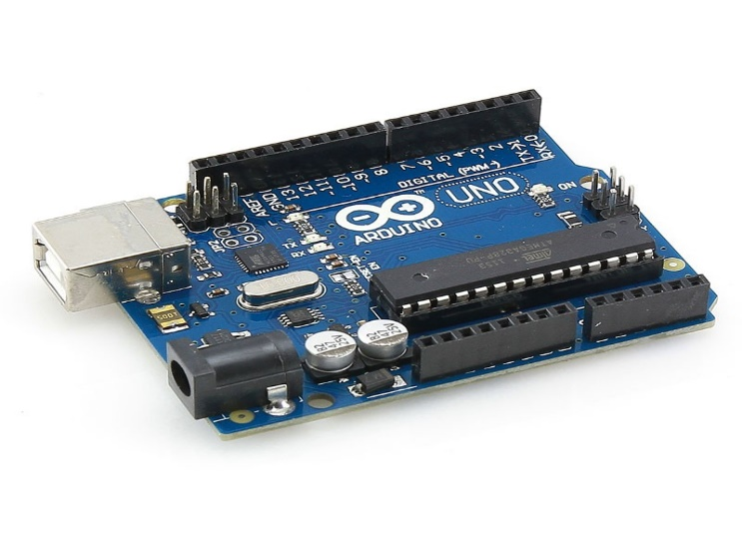In our project, we will use Arduino Uno microcontroller. The Arduino Uno is a microcontroller board based on the ATmega328. It has 14 digital input/output pins (of which 6 can be used as PWM outputs), 6 analog inputs, a 16 MHz crystal oscillator, a USB connection, a power jack, an ICSP header, and a reset button. It contains everything needed to support the microcontroller; simply connect it to a computer with a USB cable or power it with a AC-to-DC adapter or battery to get started. The Uno differs from all preceding boards in that it does not use the FTDI USB-to-serial driver chip. Instead, it features the Atmega8U2 programmed as a USB-to-serial converter.

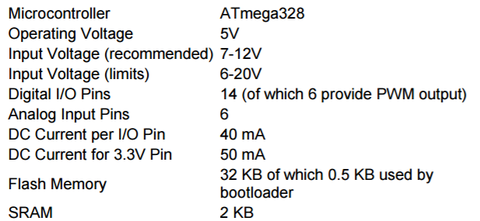

Sources: <https://www.google.com/search?q=arduino+uno+board&espv=2&biw=1163&bih=514&source=lnms&tbm=isch&sa=X&ved=0ahUKEwiavP-K5fHQAhXLrFQKHSfUA0cQ_AUIBygC#imgrc=G1l40Nj2dfTPiM%3A>

<http://www.arduino.org/products/boards/arduino-uno> <http://www.me.umn.edu/courses/me2011/arduino/arduinoGuide.pdf>

**The Test Device**

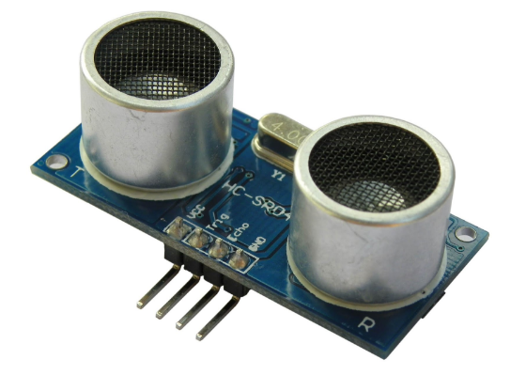For our project we will use HC-SR04 Ultrasonic Sensor. This sensor can be used as a parking sensor in real life or just for measure a distance from any object.

The [HC-SR04](http://cytron.com.my/p-sn-hc-sr04) ultrasonic sensor uses sonar to determine distance to an object like bats or dolphins do. It offers excellent non-contact range detection with high accuracy and stable readings in an easy-to-use package. From 2cm to 400 cm or 1” to 13 feet. It operation is not affected by sunlight or black material like Sharp rangefinders are (although acoustically soft materials like cloth can be difficult to detect).

**Electric Parameter**

|  |  |
| --- | --- |
| Working Voltage | DC 5 v |
| Working Current | 15mA |
| Working Frequency | 40Hz |
| Max Range | 4 m |
| Min Range | 2 cm |
| Measuring Angle | 15 degree |
| Trigger Input Signal | 10uS TTL pulse |
| Echo Output Signal | Input TTL lever signal and the range in proportion |

Sources:

<http://www.micropik.com/PDF/HCSR04.pdf>

**Development tools**

We first set up this experiment by using the Arduino IDE to verify the initial prototype and see how it worked. Upon completion of that, we set up the experiment with AVR-GCC and used the make system to build. In this experiment the microcontroller and device are run using the Linux platform. Atmel Studio was also used to aide in debugging.

**Experiment**

In this experiment we used an Arduino Uno and connected it with an Ultrasonic Sensor to determine distance to an object. The Ultrasonic Sensor has four wires attached one to the voltage power, one to the ground, and two to the breadboard. There are also three additional wires that attach the pins to the breadboard. The breadboard contains three resistors which aide in resisting the flow of electricity, a red LED- trigger, yellow LED- receiver, and green LED- obstructer. The reason we decided to do this experiment was because we were intrigued by the sensors ability and at the time were interested in incorporating that with an LCD screen.



**Conclusion**

From this experiment we were able to learn a lot more about assembly language and how to use it with device. One of the main things that we learned where register addresses were on the hardware, which is very important. In the future we would like to work more with the libraries and try to get the LCD working with this device.

**Contributions**

Daniel Valey – Project Code

Jordan Walker – Project Code

Rachel Kelmenson - Diagram

Alexander Voznesenskiy - Project Report

Steffany Vasquez – Project Report

**Project code**

main.c



timer.S





config.inc



Makefile

